Worksheet 9.3

Great ideas and lucky breaks!
Student: Class:
Read the following stories about three great scientists and their discoveries.

Jumping frogs’ legs
The very first electric cell was created by accident over 200 years ago. Luigi Galvani (1737–1798), an Italian physician, was dissecting the leg of a recently killed frog. The leg was held by a brass hook. When he cut the leg with an iron knife, the leg twitched. Galvani investigated further by hanging the frog’s legs on an iron railing with brass hooks. Whenever the frog’s legs came into contact with the iron railing, they twitched. Galvani incorrectly proposed a theory of ‘animal electricity’ as the reason behind the muscle spasms.
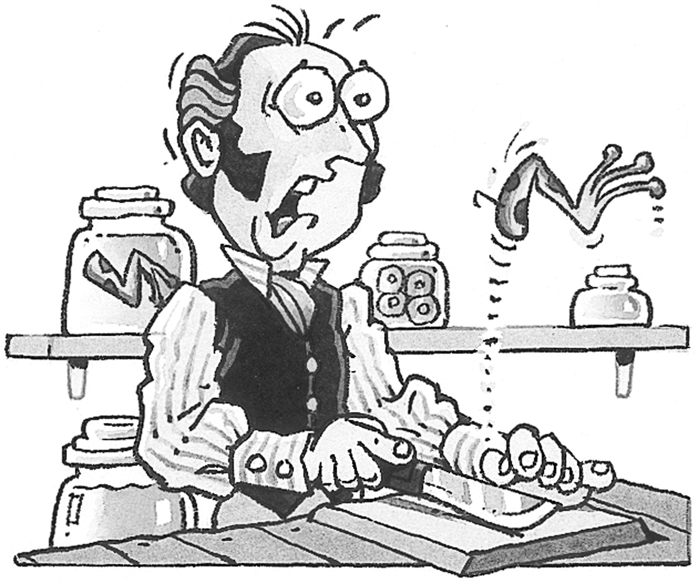
Reports of Galvani’s observations reached his friend Alessandro Volta, another Italian scientist. Volta suggested that the twitch was caused by a sudden movement of electric charge between the two different metals. The frog’s flesh, he suggested, conducted the charge. Galvani had, without realising it, produced the world’s first electric cell. The galvanometer, an instrument used to measure small electric currents, was named after Luigi Galvani.
The germ of an idea
Louis Pasteur (1822–1895) proved that infectious diseases were caused by microbes. His ideas became known as ‘germ theory’. He also developed vaccines that made people immune to several diseases, including rabies and smallpox. In doing this he has been responsible for saving the lives of millions of people and countless animals.
Pasteur began his scientific career in physics and chemistry and became interested in microbes when he was using light to investigate the differences between chemicals in living and non-living things.
Did that apple really fall on his head?
Pasteur’s next challenge was to rescue the French wine industry. Wine (and beer) became sour very quickly and this was beginning to affect the French economy, which relied heavily on the export of wine. Pasteur showed that the souring was caused by acids produced by the action of bacteria in the wine. Pasteur invented a process that rapidly heated some of the ingredients of the wine. The rapid heating killed most of the offending microbes without altering the flavour of the wine. The process, known as pasteurisation, was later adapted to slow down the souring of milk.

Falling apples
Sir Isaac Newton (1642–1727) is probably most well-known for his laws of gravitation, which explain the motion of the planets around the sun. According to some historians, his ideas about gravity arose after an apple fell on his head. We’ll probably never know if this is true.
Isaac Newton was sent to Cambridge University at the age of 18. When the university closed down in 1665 as a result of the Great Plague, young Isaac went home for two years. There he developed his laws of gravitation and his three laws of motion. During his life, he also made discoveries about the behaviour of light and invented a whole new branch of mathematics called calculus. Much of the scientific knowledge that has been acquired since the seventeenth century is built upon Newton’s discoveries during that amazing two-year period.


Worksheet 9.3

Page 2

1. Consider the discoveries made by Galvani, Pasteur and Newton. In each case, describe the skills and scientific knowledge that they used in making and developing their discoveries.

2. Write a biography similar to those presented on the previous page about one of the following scientists.
David Unaipon (1872–1967)
Peter Doherty (1940–)
Linus Pauling (1901–1994)
Barbara McClintock (1902–1992)
Stephen Hawking (1942–)

